Mobile Applications

CGP605 – AE1

James Coyle – Q13068296

Sean Khanna – Q11279516

Jamie Etting – Q12906735

Xavier Oliver – Q12286257

Contents

Design 2

Schedule and Stories 3

Project Management 3

Asset List 3

Workload 3

Risk 4

Appendix 4

Appendix A – HackNPlan 4

Appendix B – Gantt Chart 5

Appendix C – Level Design 6

Appendix D – State Diagrams 8

Appendix E – UI/UX Wireframes 8

Appendix F – UML/Class Diagrams 8

Appendix G – Character Behaviour 8

***Brief Details***

***Assessment criteria***

|  |  |  |  |  |  |
| --- | --- | --- | --- | --- | --- |
|  | *F4-F1* | *D4-C1* | *C4-C1* | *B4-B1* | *A4-A1* |
| Design  30% | *Student defines no gameplay mechanics*  *No design attempted.* | *Student displays basic gameplay mechanics however is vague on the implementation details*  *Over all system design is vague and doesn’t meet client’s requirements.* | *Student defines basic gameplay mechanics and some discussion of relation to the client goals*  *Overall system has been designed but may not entirely meet client requirements.*  *Clearly identifies individual sections of design from group design.* | *Defines a manageable definition of a gameplay mechanic with justification and design.*  *System design meets client’s goals.*  *Clearly identifies individual sections of design from group design.*  *Makes use of appropriate design tools and diagrams.* | *Student defines a well thought out mechanic with well-defined and justified design that matches client’s aim with good amount of research.*  *Clearly identifies individual sections of design from group design.*  *Makes extensive use of appropriate design tools and diagrams.* |
| Schedule  20% | *No or basic thought given to schedule* | *Sprints, or equivalent, defined and deadlines are taken into account* | *Schedule is feasible, sprints or equivalent, are defined with start and end dates. Tasks completed in the right order.*  *Tasks linked to requirements where necessary.* | *As before with critical path tasks completed.* | *Sprints or equivalent defined, deadlines met, priority taken into account, with backup plans discussed. All the information can be understood quickly* |
| Project Management  10% | *No methods in place to track work*  *No project management plan* | *Tools proposed but lacking justification.*  *Defines basic project management plan.* | *Tool selected with basic reasoning.*  *Defines good project management plan.* | *Tool selected and research into other options, well researched justification of choice.*  *Defines well thought out project management plan.* | *As before, with links to the specific examples of possible use in the projects.*  *Defines excellent project management plan with almost no errors.* |
| Workload  20% | *Very little or no allocation of workload or unfairly balanced with not rational.* | *Displays an understanding of stories assigned and some basic refining of tasks* | *Displays a well thought out breakdown of the stories and some basic time scales with fair allocation of tasks or rational to explain unfair allocation.* | *As before with more defined scales including dependencies and priorities.*  *Includes a basic critical path.* | *As before, including justification for task allocation and order. Further task refinement and alt critical paths for alternative planes.* |
| Risk  20% | *No Risks discussed* | *Risks are general and easily solved* | *Risks are linked to user stories or equivalent but no solutions proposed* | *Risks are linked to user stories poor solutions are suggested* | *Well thought out risks that are related to the stories and suitable solutions proposed* |

***Scenario***

*Your indie company has been approached by The Thomas Publishing group to create a mobile game that will be free to play and generate revenue from alternative means, such as advertising. You are free to create any game you wish but remember that the final product MUST be of release quality, excluding art, this can be improved later by an artist.*

*You must submit a game proposal to Thomas publishing (the lecturer) for summative feedback by week 3, so that Thomas publishing have an idea of your project and the time scales you have set yourselves. This document will cover the core game mechanics, project management strategies and an initial design for you game systems. The core design is left up to you, since you’re an expert in the field of game development.*

*You will be using this document as the plan to complete the project and Assessment 2.*

***Technical brief:***

* *The game must be able to run on a mobile device.*
* *The game should be suitable for play on android, using any of the available input methods, virtual keyboard, accelerometer, touch screen, etc.*
* *The game must log a high score at the end of the play session.*
* *The game must be of release quality, i.e.*
  + *it should have not game breaking bugs*
  + *it should utilise a loading screen where needed to so that the game doesn't look like it has frozen.*
* *Your game must utilize a virtual currency that should be spendable on in game items (power ups, skins, etc.). You may implement loot boxes if you wish.*

# Design

[Team]

*This discusses the design of the game, what the core gameplay mechanics are, how the game is played. Provide a brief over view of the system design (you do not need to stick rigidly to this designs, it’s just there as a foundation for the rest of your project.*

|  |  |  |  |  |  |
| --- | --- | --- | --- | --- | --- |
| Design  30% | *Student defines no gameplay mechanics*  *No design attempted.* | *Student displays basic gameplay mechanics however is vague on the implementation details*  *Over all system design is vague and doesn’t meet client’s requirements.* | *Student defines basic gameplay mechanics and some discussion of relation to the client goals*  *Overall system has been designed but may not entirely meet client requirements.*  *Clearly identifies individual sections of design from group design.* | *Defines a manageable definition of a gameplay mechanic with justification and design.*  *System design meets client’s goals.*  *Clearly identifies individual sections of design from group design.*  *Makes use of appropriate design tools and diagrams.* | *Student defines a well thought out mechanic with well-defined and justified design that matches client’s aim with good amount of research.*  *Clearly identifies individual sections of design from group design.*  *Makes extensive use of appropriate design tools and diagrams.* |

# Schedule and Stories

[Team]

*Here you’ll take the dates supplied and create your project plan appropriately. This section should be easy to read and convey the stories that need to be completed, by whom and when.*

|  |  |  |  |  |  |
| --- | --- | --- | --- | --- | --- |
| Schedule  20% | *No or basic thought given to schedule* | *Sprints, or equivalent, defined and deadlines are taken into account* | *Schedule is feasible, sprints or equivalent, are defined with start and end dates. Tasks completed in the right order.*  *Tasks linked to requirements where necessary.* | *As before with critical path tasks completed.* | *Sprints or equivalent defined, deadlines met, priority taken into account, with backup plans discussed. All the information can be understood quickly* |

# Project Management

[Team] (Tracking System)

*What tools will you use to track your project development and keep your project files safe?*

|  |  |  |  |  |  |
| --- | --- | --- | --- | --- | --- |
| Project Management  10% | *No methods in place to track work*  *No project management plan* | *Tools proposed but lacking justification.*  *Defines basic project management plan.* | *Tool selected with basic reasoning.*  *Defines good project management plan.* | *Tool selected and research into other options, well researched justification of choice.*  *Defines well thought out project management plan.* | *As before, with links to the specific examples of possible use in the projects.*  *Defines excellent project management plan with almost no errors.* |

# Asset List

[Team]

*Here is a list of the art and audio assets that are required to make the game. Artwork will be provided either form the group or from students on other courses in the university.*

# Workload

[Individual]

*Break down of stories assigned to you. This will be a concise description and any further tasks required.*

|  |  |  |  |  |  |
| --- | --- | --- | --- | --- | --- |
| Workload  20% | *Very little or no allocation of workload or unfairly balanced with not rational.* | *Displays an understanding of stories assigned and some basic refining of tasks* | *Displays a well thought out breakdown of the stories and some basic time scales with fair allocation of tasks or rational to explain unfair allocation.* | *As before with more defined scales including dependencies and priorities.*  *Includes a basic critical path.* | *As before, including justification for task allocation and order. Further task refinement and alt critical paths for alternative planes.* |

# Risk

[Individual]

*Highlight stories that you think may cause problems in the development cycle.*

|  |  |  |  |  |  |
| --- | --- | --- | --- | --- | --- |
| Risk  20% | *No Risks discussed* | *Risks are general and easily solved* | *Risks are linked to user stories or equivalent but no solutions proposed* | *Risks are linked to user stories poor solutions are suggested* | *Well thought out risks that are related to the stories and suitable solutions proposed* |

# Appendix

***Scenario***

*Your indie company has been approached by The Thomas Publishing group to create a mobile game that will be free to play and generate revenue from alternative means, such as advertising. You are free to create any game you wish but remember that the final product MUST be of release quality, excluding art, this can be improved later by an artist.*

*You must submit a game proposal to Thomas publishing (the lecturer) for summative feedback by week 3, so that Thomas publishing have an idea of your project and the time scales you have set yourselves. This document will cover the core game mechanics, project management strategies and an initial design for you game systems. The core design is left up to you, since you’re an expert in the field of game development.*

*You will be using this document as the plan to complete the project and Assessment 2.*

## Appendix A – HackNPlan

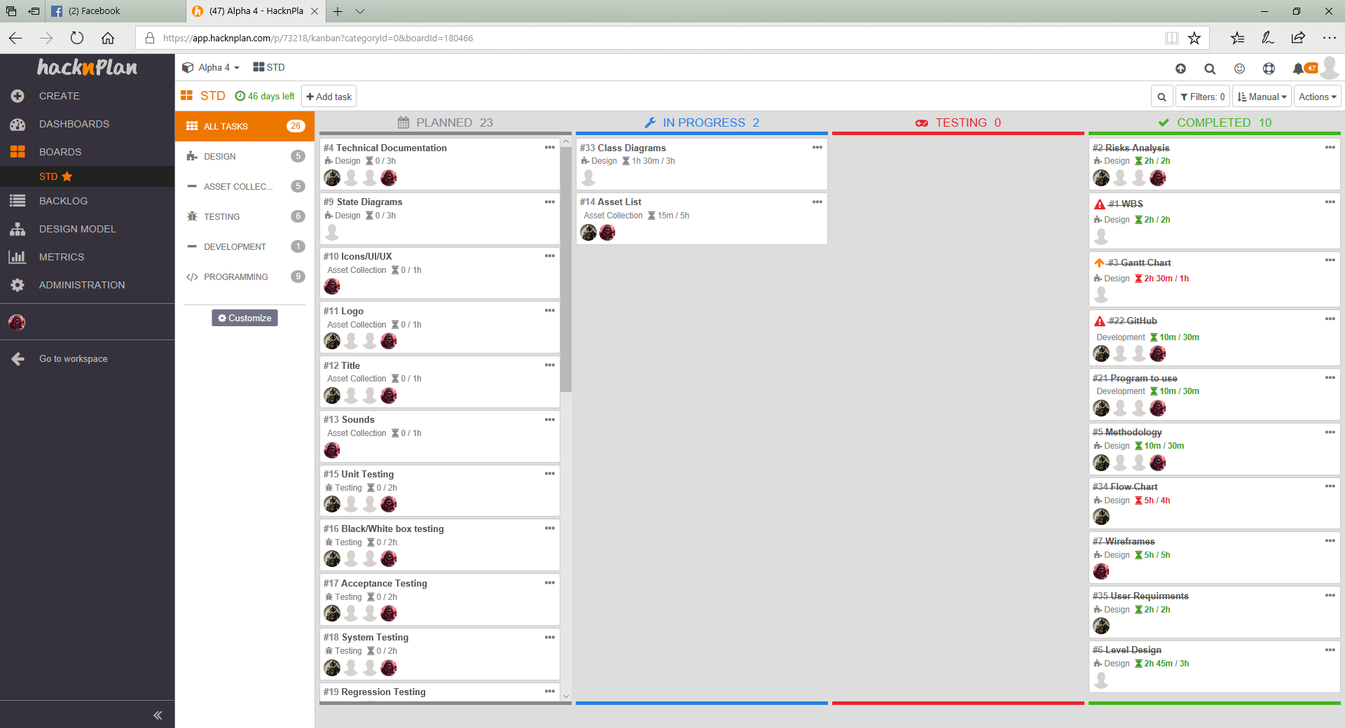

(Access available upon request)

**Appendix created by James Coyle**

## Appendix B – Gantt Chart

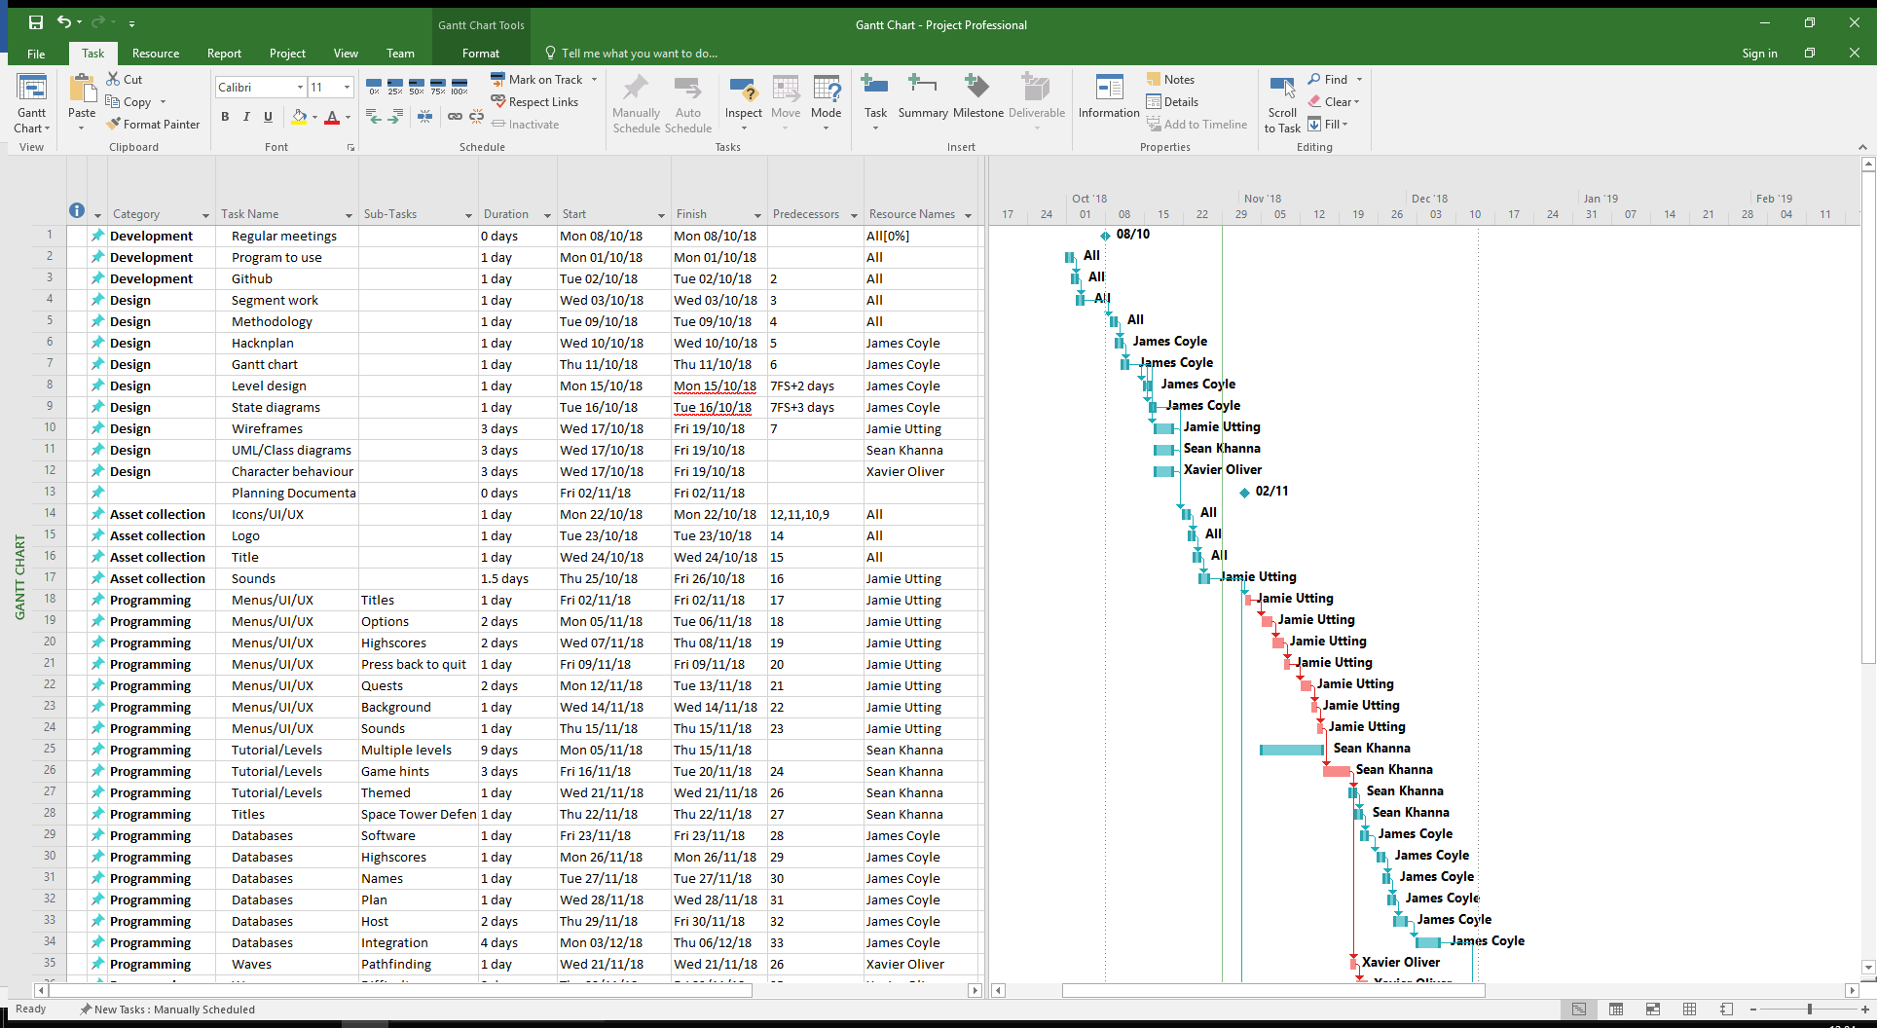 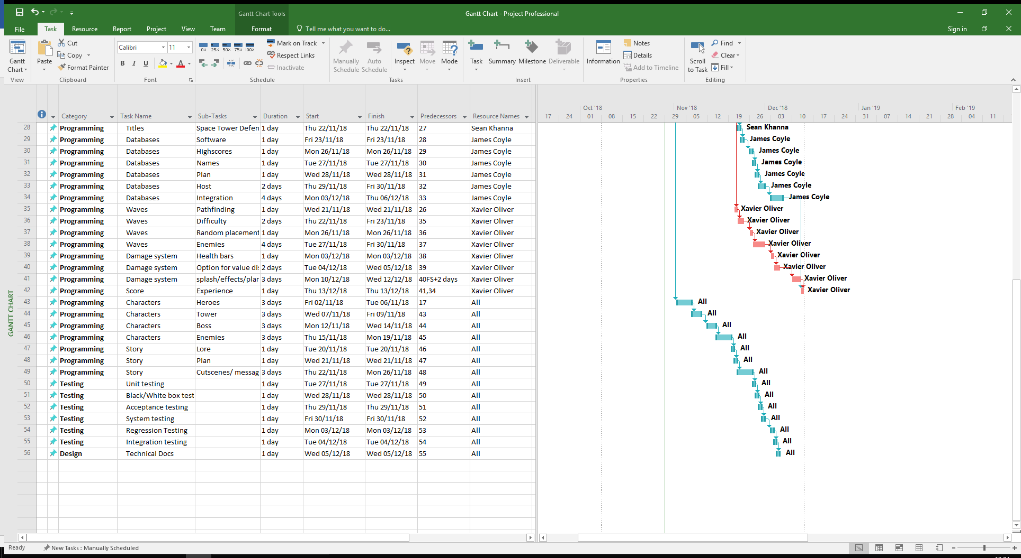

**Appendix created by James Coyle**

## Appendix C – Level Design

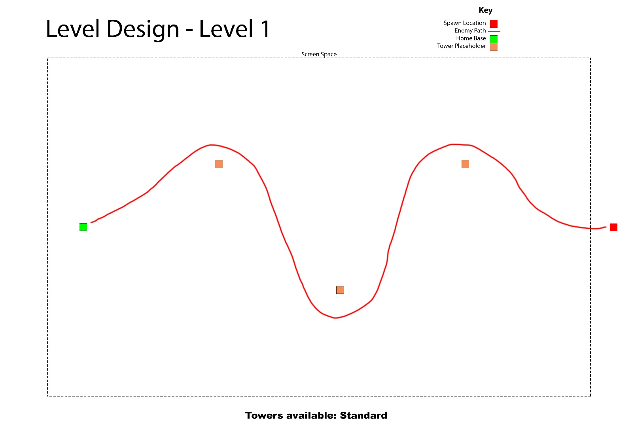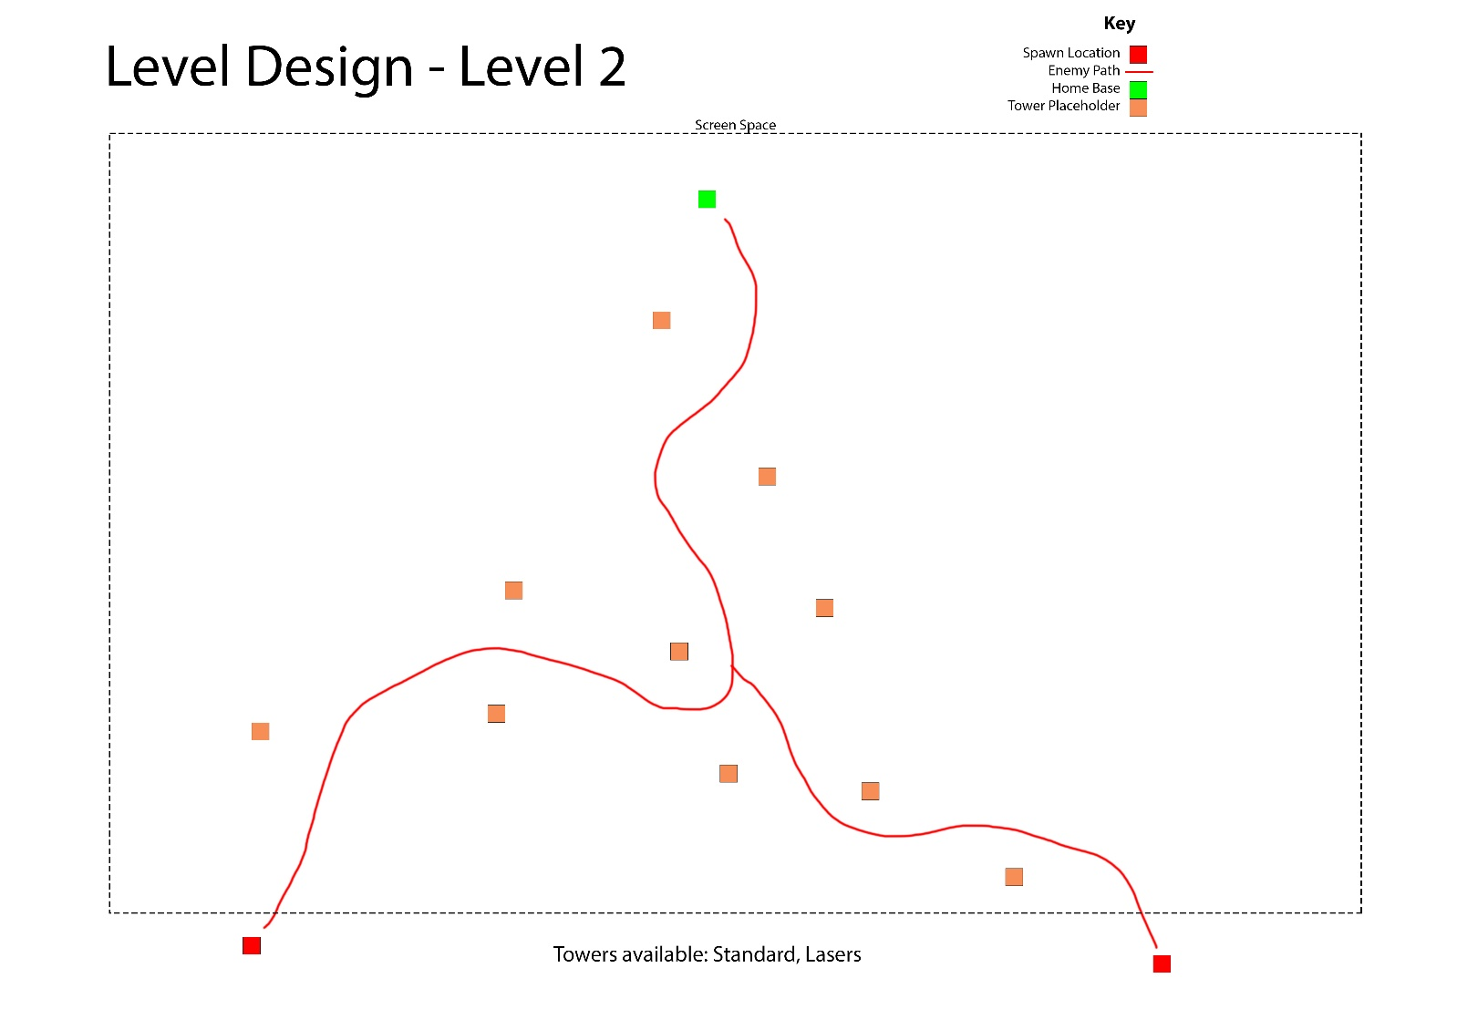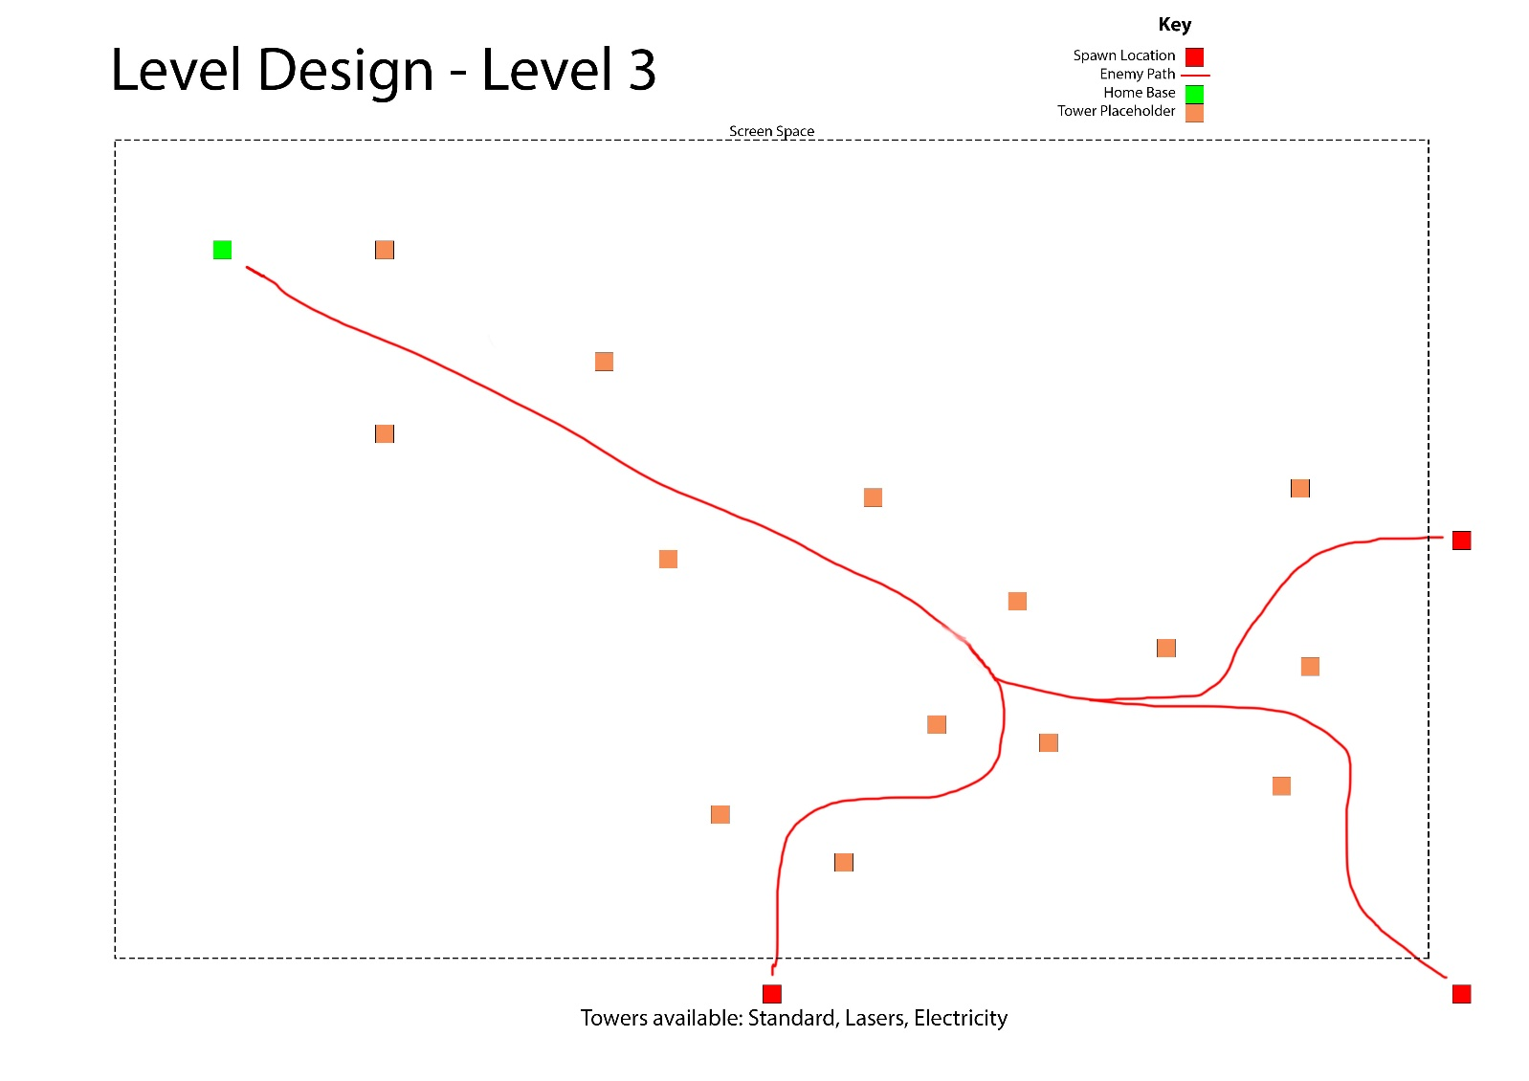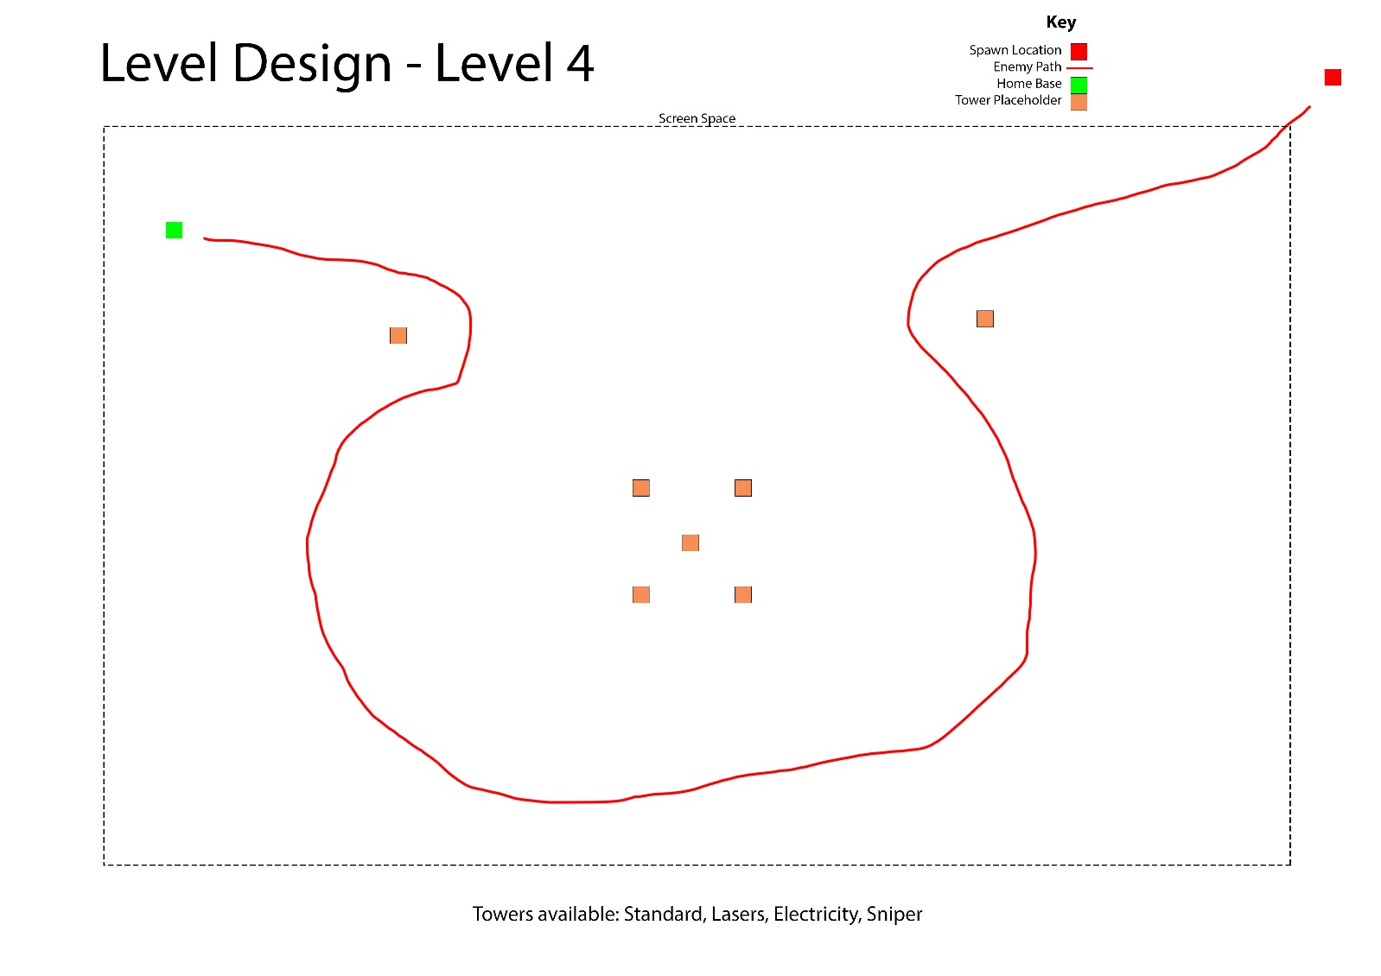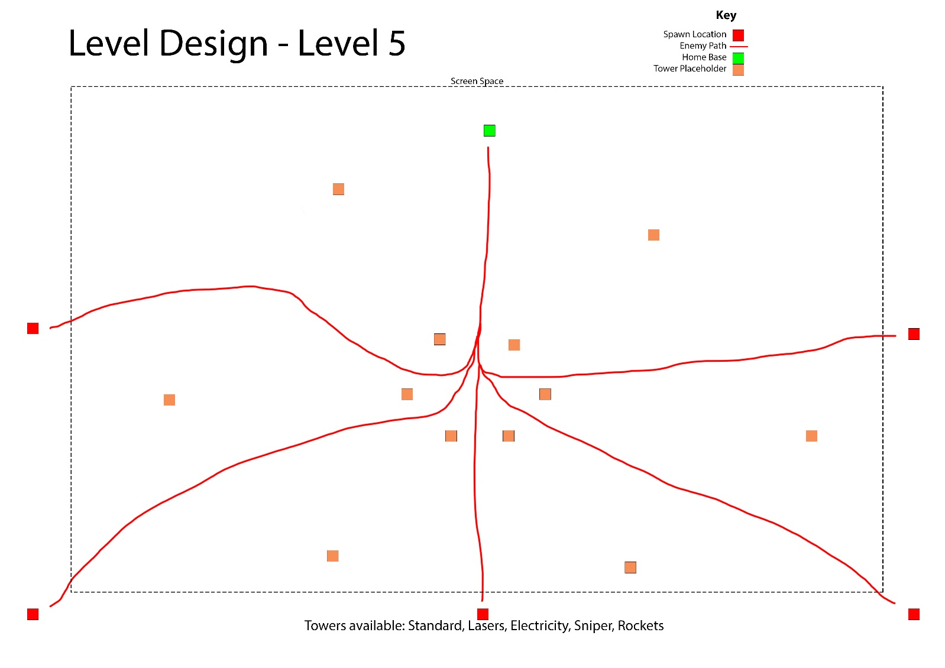

**Appendix created by James Coyle**

## Appendix D – State Diagrams

**Appendix created by James Coyle**

## Appendix E – UI/UX Wireframes

**Appendix created by Jamie Utting**

## Appendix F – UML/Class Diagrams

**Appendix created by Sean Khanna**

## Appendix G – Character Behaviour

**Appendix created by Xavier Oliver**

## Appendix H – Asset List

**Appendix created by Xavier Oliver**